Wool Committee  President: Isabell van Millingen  Vice President: Michelle Leonard/  Sue Ealden  Treasurer: Sue Burden/Suzie Crowe  Secretary: Catherine Manners  Min Secretary: Harriet Green  Programme Secretary:  June Axon/Catherine Manners  New Members: Sarah Gardiner  MCS: Michelle Leonard  Tess Burt  June Hedges  Sharon Palmer  -----------------  Group Representative: Sue Ealden  Email: Woolwi@dorsetwi.org  Website: www.wi-wool.weebly.com  Group Meeting  27th September 2023  Annual Council Meeting  12th October 2023 | D.F.W.I. Office  18 Crown Street West,  Poundbury  Dorchester.  Dorset  Tel: 01305 266366  Email: dorsetwi@uwclub.net  Website: dorsetwi.co.uk  Office Hours  Monday Tuesday & Wednesday  10.00am – 1pm  Thursday & Friday Closed | 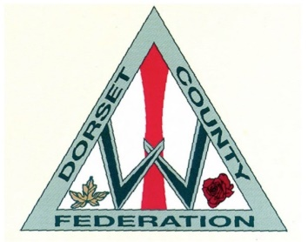  the WI  INSPIRING WOMEN  Wool WI  Monthly Meetings  2nd Monday of the month  Oct - March  At 2.00 pm – 4.00 pm  April – September  At 7.00 pm – 9.00 pm  The Kids of Wool Building  The D’Urberville Centre  Colliers Lane  Wool  Dorset BH20 6DL  Programme  2023/2024
2023  11th September  ‘How to write a book’  Christine Lawford  9th October  ‘From Court Shoes to Combats and back again’  Sally Cadec  13th November  All about Recycling  Martin Gregory (Dorset Council)  11th December  Christmas Meal  2024  8th January  Resolutions  12th February  TBC  11th March  ‘In house’ activity | 15th April  TBC  13th May  Project Linus  10th June  Garden Meeting  8th July  Annual Meeting  Clubs  Monthly Rambles  1st Wednesday of the month.  Meet at The D’Urbeville Car Park 10.00am  Angela Millington Tel: 01929 463872  Monthly Lunch Club  Ann Cobley Tel: 01929 462046  Skittles Matches  Kath Burt Tel: 01929 462171  Suzie Crowe Tel: 01929 401566  Monthly Sewing Bee  Sarah Gardiner Tel: 01929 401542 | Tea Hostesses 2023/2024  September  Jenny Key, Lynne Avery, Pam Fraser  October  Jane Windsor, Valerie Wilson, Marilyn Holehouse  November  Ali Burnel, Danzella Trask, Patricia Keen  January  Ann Woodhead, Sheila Linter, Carol Maslan  February  Virginia McDermid, Pam Tolley, Kath Burt  March  Angela Millington, Sue Sweetland,  Maureen Quinn  April  Sally Childs-Slade, Patricia Hook,  Sandra Housego  May  Ann Cobley, Shehnaz Jackson, Jill Ley  July  ANNUAL MEETING

